

T15 12 VOLT FLEXI SEEDER SMALL SEED DRILL 120 AND 300 LITRE CAPACITIES

INSTRUCTION BOOK

Please read instruction book before operating machine.

Bullock Tillage

Mill Farm, Mill Lane, Malvern

Telephone: 01684310112 Nigel Bullock: 07850825980

Ross Pushman : 07815110529

BULLOCK TILLAGE

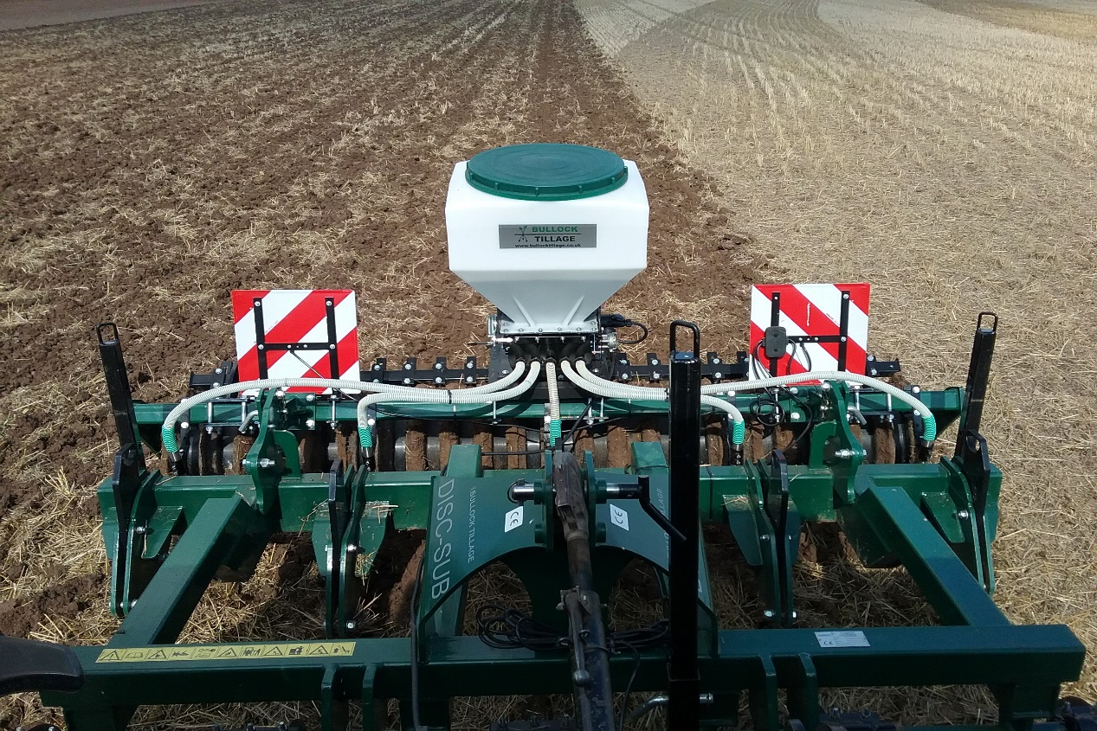

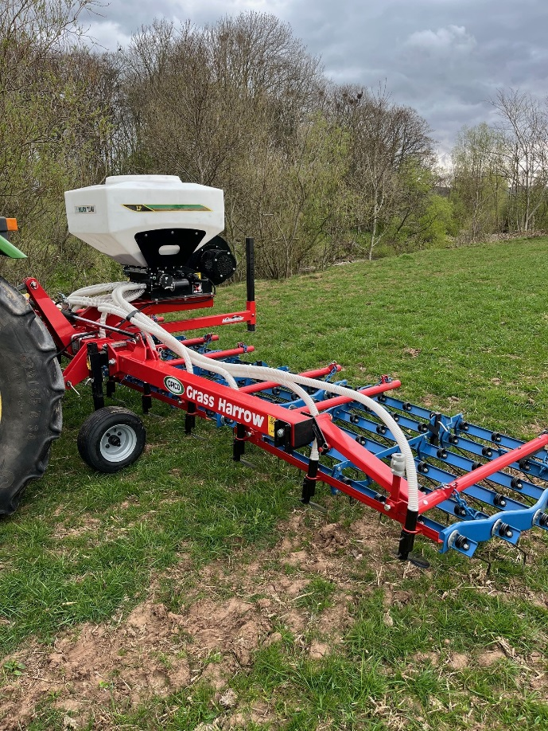

BULLOCK TILLAGE

CONTENTS PAGE

Technical specifications 1

Fitting/electrical connection/tension spring 2

Changing the seed rotor 3

Cleaning and maintenance 4

Finger switch control 5

Calibration latch and slide 6

Hydraulic fan and cable support 7

Standard control box 8

GPS Control box 9

GPS Control box 10

Calibration 11

Settings for the Green rotor 12

Settings for the Yellow rotor 13

Settings for Red rotor 14

Safety instructions 15

BULLOCK TILLAGE

T15 TECHNICAL SPECIFICATIONS

120 litre capacity: 300 litre capacity:

Weight: 40 kg when empty. Weight: 60kg when empty
Dimensions: 600mm wide Dimensions: 670mm wide
800mm high 900mm high
600mm deep 1,000mm deep
Blower pipe: 25mm diameter internal. Blower pipe: 30mm diameter internal.

Supply voltage: Two 12 volt motors
Blower motor: 170 watts
Rotor motor: 100 watts

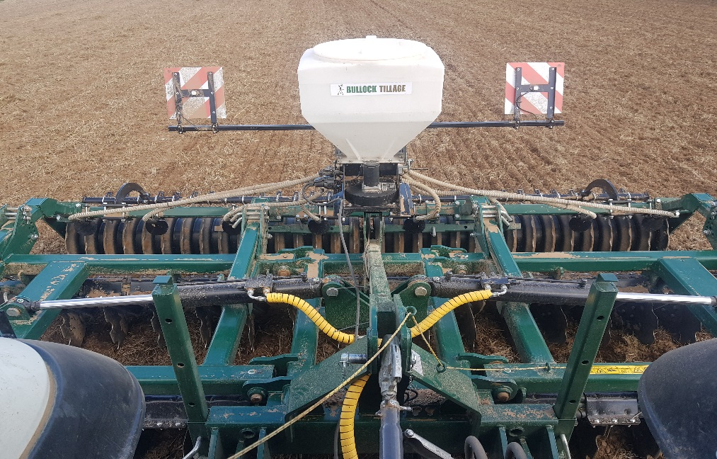

1.

FITTING AND ELECTRICAL CONNECTION

Fit the Flexi Seeder in the centre of the implement and check it is securely bolted into position. Try and allow sufficient space under the seeder to collect seed from the trap beneath the rotor for calibration.

The 120 litre seeder draws air in below the fan unit so allow room for air to circulate and avoid putting a flat plate directly under the unit.

When fitting the pipes to the outlets the pipes should always slope downhill to avoid any potential blockages.

If spreader plates are fitted they will spread seeds approximately 70cm on average, 35 cm either side of the plate.

If sufficient power is not provided from the socket within the tractor cab, then source power direct from the tractor battery and protect with a 30 amp fuse.

THE TENSION SPRING

The tension spring adjusts the pressure of the flaps on the rotor inside the hopper. The tension spring may need adjusting when
a larger rotor is fitted. Adjustment is made by moving the bolt to a different hole on the circular disc.

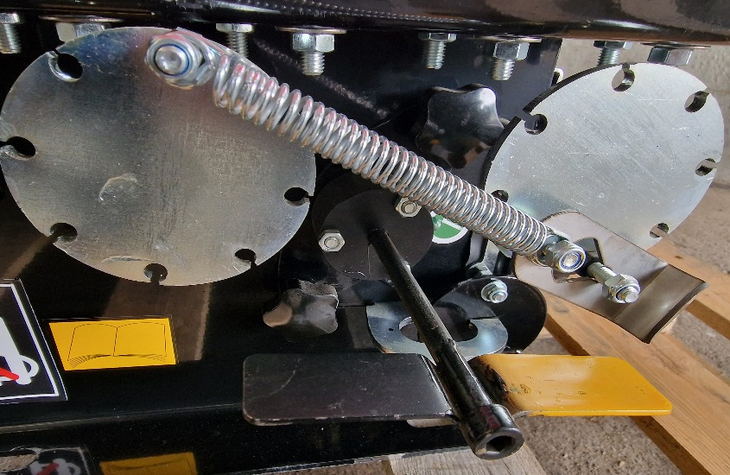
2.

CHANGING THE SEED ROTOR

Three types of seed rotor are available depending on the size of seed to be sown. Green for small seeds, stainless steel (yellow) for larger seeds and red for large seeds and grass seed.

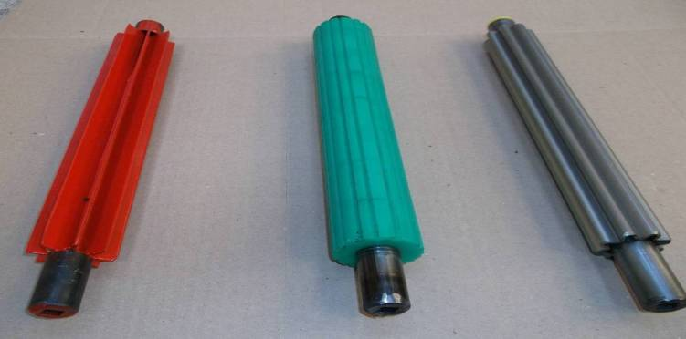

To change the seed rotor disconnect the tension spring on the side of the seeder then unthread the yellow and black indicator paddle and unscrew the two retaining buttons, take off the trap and pull the rotor out, put in the new rotor square hole first then replace the trap retaining buttons, re-attach the tension spring and thread the indicator paddle into position.

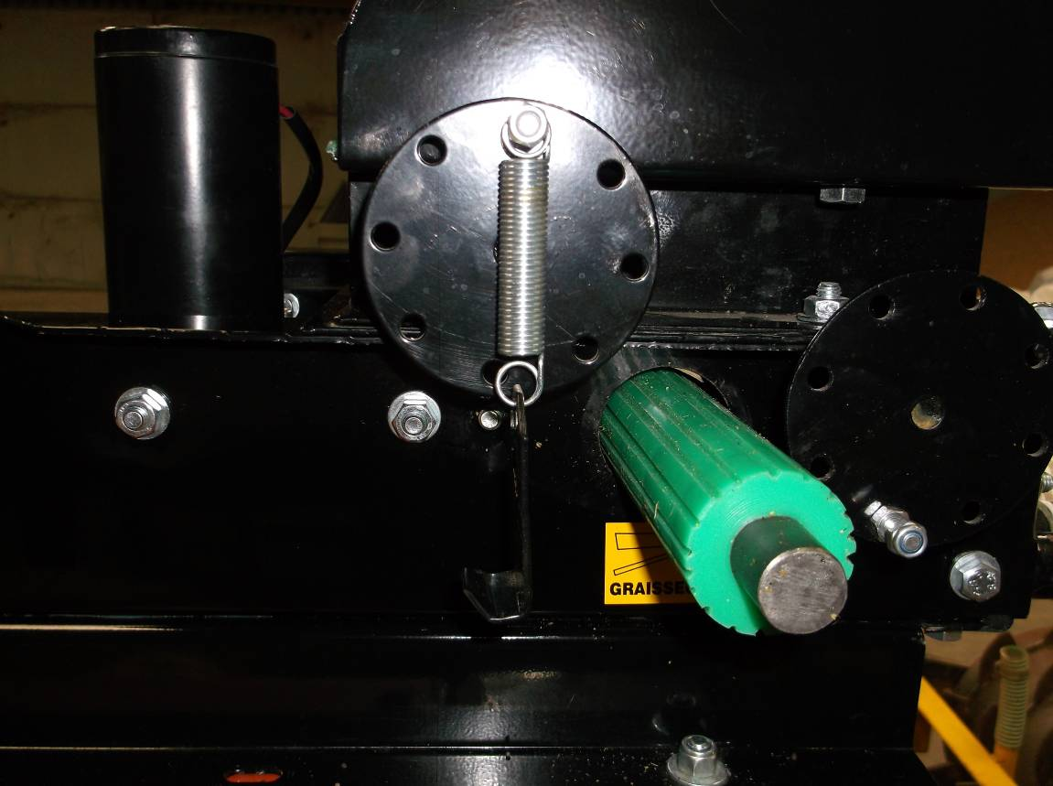

3.

CLEANING AND MAINTENANCE

There are two greasing points on either end of the seed rotor. These will need regular greasing (every 50 hours) especially in dusty conditions to avoid the rotor from seizing.

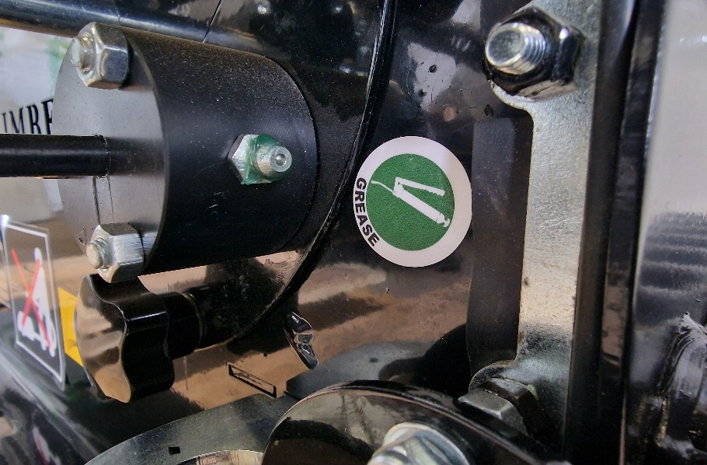

Do not use a pressure washer on the applicator because of the electrical components.

Use an airline to blow dust from the applicator especially around the fan unit intake.

Always empty and clean the applicator after use to avoid damage from seed or vermin.

Store the applicator under cover.

4.

FINGER SWITCH CONTROL AND PLUG

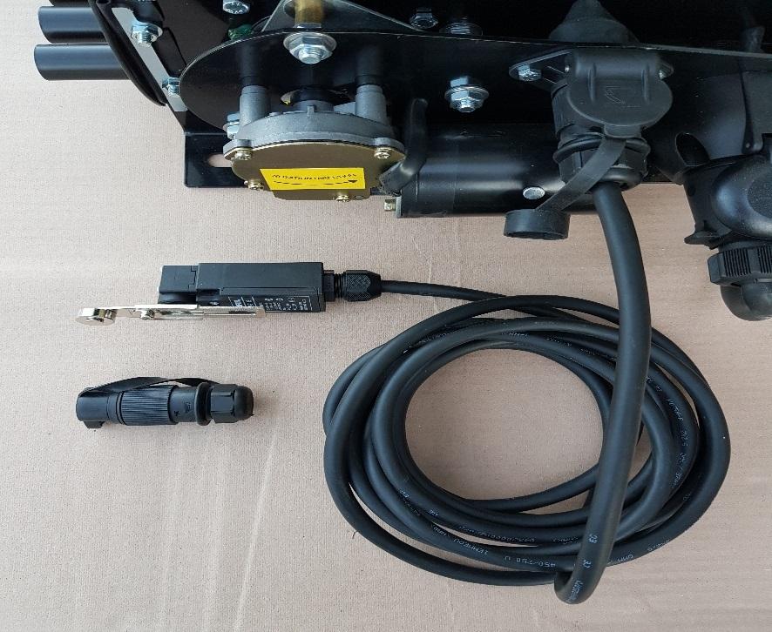

The applicator comes supplied with a finger switch control which can be plugged in just above the rotor motor having first removed the blank plug. When the finger switch is not being used the blank plug must be replaced to enable the electrical connection to be resumed.
The finger switch needs to be positioned to any section of the machine or tractor, for example top link, that will move and hold the switch when the implement is raised and so automatically disengage the power to the rotor motor and then when lowered the rotor motor will re-engage. This system is almost essential when using the GPS control box.

5.

CALIBRATION LATCH AND SLIDE

On the side of the applicater there is a slide that is removed by raising a latch that then allows the seed to fall out into a collection vessel to be weighed for calibration purposes. When positioning the seeder onto an implement, if possible allow room under the rotor to be able to put a bag or bucket so the seed can be caught for weighing.

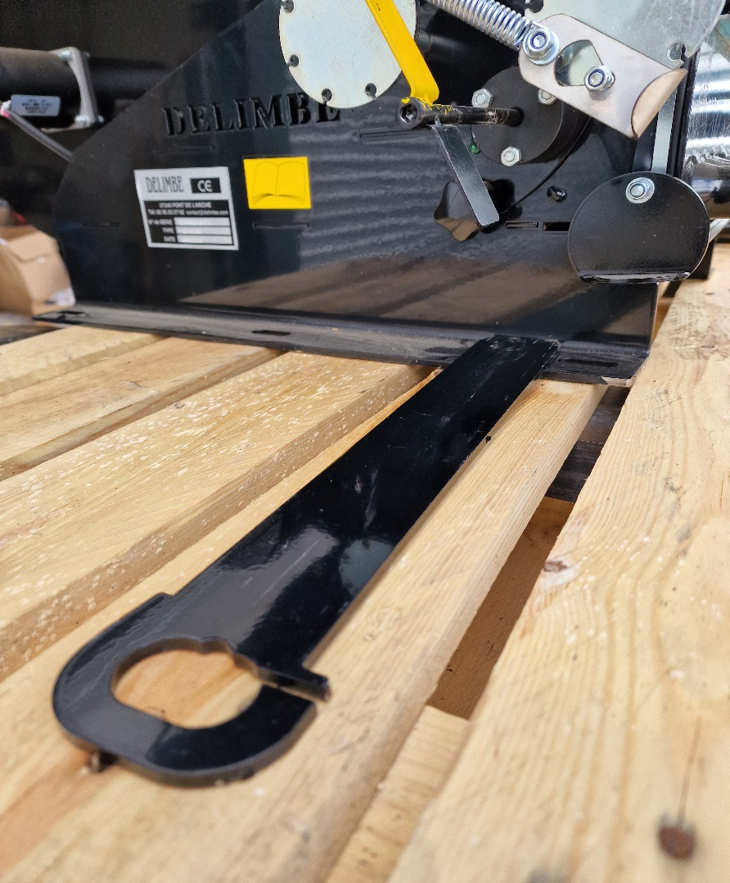

6.

HYDRAULIC DRIVEN FAN ON 300 LITRE SEEDER

The 300 litre airseeder is available with hydraulic drive which enables it cover up to working widths of 9 metre.

The unit comes with a flow and return hydraulic pipe.

The pressure gauge on the fan motor indicates the oil pressure passing through the pump.

Connect the flow and return pipes to the tractor and turn the pressure down on the tractor hydraulic valve. Slowly increase the pressure until the pressure gauge shows a reading of 20 bar pressure. Avoid pressures above 20 bar as it can damage the pump and seals.

ELECTRICAL CABLE SUPPORT

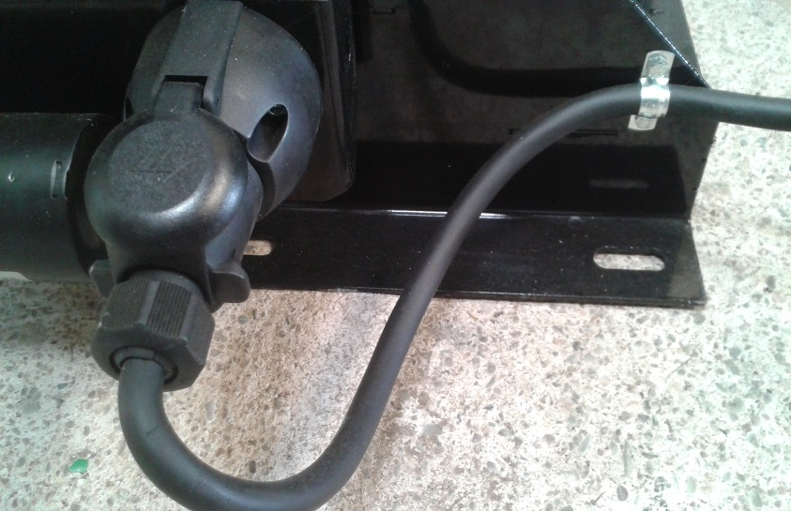

When plugging in the control box always use the cable support to avoid pressure on the control cable.

7.

T15 STANDARD CONTROL BOX.

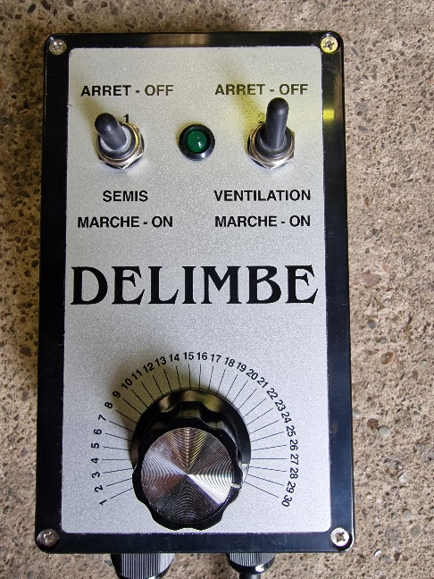

The control box has three functions:
- Top left is the rotor switch which has three positions: 1. Held in the top position for calibration 2. Central position to switch off 3. Bottom position for work.
- Top right on/off for the fan.
- Below is the dial to adjust rotor speed for calibration.

When calibrating with the standard control box the top left hand switch is held in the up position for one minute so the rotor turns and the seed can be collected.

Always calibrate with the lid firmly in place on the applicator.

8.

T15 GPS CONTROL BOX

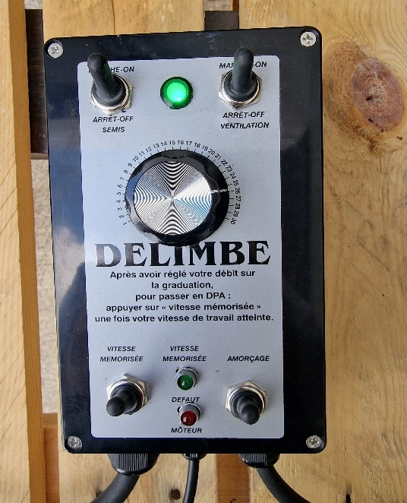

The GPS control box has four switches and a dial for calibration.
- Top left is switch for the rotor. The top position is the work position. In the centre the rotor is switched off. The lower position held down is for calibration.
- Top right switch operates the fan motor.
- Bottom left is the speed memorise switch which is depressed and released when you reach the chosen calibration speed in the field, the GPS then operates around this speed setting.
- Bottom right is the pre-charge and calibration switch. This switch is held down along with the top left hand switch for calibration purposes. This switch can also be depressed when backing into corners of fields as it will pre- charge the rotor with seed to avoid any gaps.
- The small green and red light indicate if the rotor is turning, green for go and red if it is not turning.

9.

GPS CONTROL BOX CONTINUED

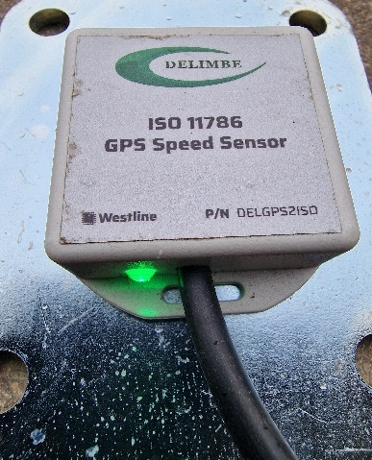

Position the GPS receiver outside of the tractor cab onto a metal surface as it is magnetic and where it has uninterrupted view towards the sky.
The receiver may take a couple of minutes to connect to a satellite and when it does the green light will brighten significantly.

To calibrate the applicator hold down the seed rotor on/off switch, top left, and the pre charge switch, bottom right, for one minute, collect the seed below the applicator and follow the instructions for the seed calibration equation on page 10.

Once the applicator is calibrated, in the field drive at the required working speed with the implement in the working position for a few metres with fan and rotor switched on and then press down and release the memory switch, bottom left, the speed memory will then be set. If the seed rotor is switched off it will be necessary to set the speed memory switch again.

10.

CALIBRATION

All applicators are calibrated in kilogrammes per hour.
The calibration calculation is:
Working width(m) x forward speed (km/hr) which gives you hectares per hour. Now multiply the hectares per hour by the desired seed rate and the result is the kilogrammes per hour. Now look in the settings table for the chosen rotor and the kg/hr has a number which relates to the dial setting on the control box.

Example:
A T15 120 litre Flexiseeder mounted on a 3 metre cultivator planting oil seed rape with a green rotor traveling at 10km/hour at a seed rate of 4kg/hectare:

3 metre x 10 km/hr = 30,000 m2 = 3.0 ha/hour

3 ha/hr x 4 kg/ha = 12 kg/hr

12 kg/hr in the green rotor settings table is between dial setting 8 or 9 on the dial. Now set the dial between 8 or 9 on the control box dial.

Now check the calibration setting. Release the latch and pull out the slide from under the rotor and place a tray, bag or bucket under the machine, run the applicator for one minute, collect the seed, weigh it and multiply by 60 to check the flow rate per hour. If necessary adjust the control box variator up or down and run the test again to check the flow rate.

Please note:
The calibration is a guide and not a guarantee of seed rate as climatic conditions, seed coatings etc, can all influence seed flow especially when a mixture of seeds are being sown. Therefore, when operating the applicator, always check visually the amount of seed being sown and adjust the dial accordingly. Try and select a rotor that gives a flow rate with a setting that is as near as possible to the centre setting (15) on the dial of the control box.

11.

15 settings table for the green rotor, small seeds, oil seed rape.

Dial setting | 120 litre applicator kg/hour | 300 litre applicator kg/hour
No 4 | 4.8 | 5.31
No 5 | 6.27 | 7.44
No 6 | 7.68 | 8.50
No 7 | 8.78 | 9.72
No 8 | 10.81 | 11.96
No 9 | 12.90 | 14.27
No 10 | 15.75 | 17.43
No 11 | 18.43 | 20.40
No 12 | 21.67 | 23.99
No 13 | 26.60 | 29.44
No 14 | 29.70 | 32.87
No 15 | 33.79 | 37.79
No 16 | 36 | 39.85
No 17 | 39.69 | 43.93
No 18 | 43.13 | 47.73
No 19 | 45.57 | 50.44
No 20 | 47 | 52.02
No 21 | 48 | 53.13
No 22 | 48.76 | 53.97
No 23 | 49.28 | 54.55
No 24 | 51 | 56.45
No 25 | 52 | 57.56
No 26 | 53.5 | 59.22
No 27 | 54.5 | 60.32
No 28 | 57.6 | 63.76
No 29 | 58 | 64.20
No 30 | 59.5 | 65.86

These settings are guide lines and flow rate should always be visually checked as weather conditions and product will all determine seed rate.

12.

T15 settings table for the stainless steel (yellow) rotor.

Dial Setting | 120 litre applicator kg/hour | 300 litre applicator kg/hour
No 4 | 6 | 6.64
No 5 | 6.4 | 7.08
No 6 | 7.2 | 7.97
No 7 | 8.8 | 9.74
No 8 | 10.4 | 11.51
No 9 | 12 | 13.28
No 10 | 14.4 | 15.94
No 11 | 16.8 | 18.60
No 12 | 20 | 22.14
No 13 | 23.2 | 25.68
No 14 | 26.4 | 29.22
No 15 | 30.4 | 33.65
No 16 | 33.6 | 37.19
No 17 | 36.8 | 40.73
No 18 | 40.8 | 45.16
No 19 | 44 | 48.70
No 20 | 47.2 | 52.24
No 21 | 50.4 | 55.79
No 22 | 52.8 | 58.44
No 23 | 55.2 | 61.10
No 24 | 57.6 | 63.75
No 25 | 61.6 | 68.18
No 26 | 64 | 70.84
No 27 | 68.8 | 76.15
No 28 | 72 | 79.69
No 29 | 76 | 84.12
No 30 | 80.8 | 89.43

These settings are guide lines and flow rate should always be visually checked as weather conditions and product will all determine seed rate.

13.

T15 settings table for the red rotor large seeds/grass seed.

Dial setting | 120 litre applicator kg/hour | 300 litre applicator kg/hour
No 4 | 14 | 15.50
No 5 | 18 | 19.92
No 6 | 22 | 24.35
No 7 | 26 | 28.77
No 8 | 30 | 33.21
No 9 | 34 | 37.63
No 10 | 38 | 42.06
No 11 | 42 | 46.49
No 12 | 46 | 50.92
No 13 | 49.5 | 54.79
No 14 | 53 | 58.66
No 15 | 56.5 | 62.53
No 16 | 60 | 66.41
No 17 | 63.5 | 70.28
No 18 | 67 | 74.16
No 19 | 70 | 77.48
No 20 | 73 | 80.80
No 21 | 76 | 84.12
No 22 | 79 | 87.44
No 23 | 82 | 90.76
No 24 | 85 | 94.08
No 25 | 88 | 97.40
No 26 | 91 | 100.72
No 27 | 94 | 104.04
No 28 | 97 | 107.36
No 29 | 100 | 110.68
No 30 | 103 | 114.00

These settings are only guide lines and flow rate should always be visually checked as weather conditions and product will all determine seed rate.

14.

SAFETY INSTRUCTIONS

Disconnect the applicator from the battery or any other power supply before doing any work on it.

Make sure no one is in operating zone when the machine is working.

Regularly check that all nuts and bolts are tight on the applicator.

Keep the applicator clean so inspection and potential problems can be easily noticed.

The seed or pellets used in the applicator may be toxic. It is essential to wear a face mask and protective clothing when filling and emptying the applicator.

Be aware and keep up to date with legislation and good practice procedures for the application of slug pellets and other products spread through the applicator.

When in use keep the hopper lid securely in place as the hopper is pressurised.

Store the applicator under cover.

Do not use a pressure washer to clean the applicator because of electrical components.

15.

